Results from a pilot Argo float program in the SOUTHeastern Indian Ocean

Ming Feng and Susan Wijffels

CSIRO Marine Research, Hobart, Tasmania, Australia

In October 1999, 10 automated profiling floats were deployed in the southeastern Indian Ocean, the Indonesian Throughflow region, by R/V Franklin, merchant ships, and Royal Australian Navy (Fig. 1). The floats are programmed for an 'Argo' mission: that is, to drift at 2000m and profile to the surface every 10 days. Manufactured and ballast by Webb Research Corporation, these PALACE R1 floats are equipped with Seabird CTDs, measuring temperature and salinity values from 50 depths and delivering data in real-time through Service Argos during their surface drift.

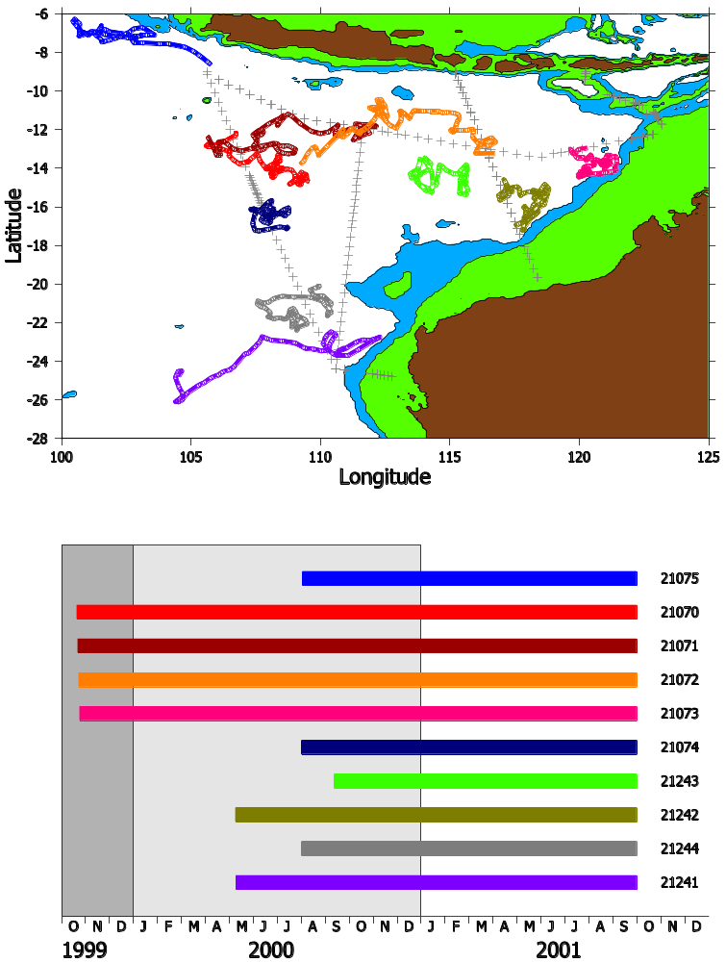

Fig. 1: (upper panel) The trajectories of the floats and (lower panel) their time span since deployments. The upper panel also shows the 1000m (green) and 2000m (blue) isobaths.

The float salinity is calibrated using recent high-resolution CTD data for potential temperatures between 2-2.8ºC. The CTD casts used for the calibration are shown as gray crosses in the upper panel of Fig. 1. The calibration results are shown in Fig. 2. The salinity sensors of the first four floats were contaminated by TBTO, the substance used as the biocide to eliminate biological fouling inside the conductivity cell. The contamination caused a freshening bias in salinity, which disappeared within a few casts, except for float 21073. There are also weak salinity drifts apparent in most floats, of the order of 0.01 psu/50 profiles. Two floats have larger drifts: 21242 of 0.03 psu and 21243 of more than 1 psu. The variability in the 21241 at its last few profiles is likely due to that the fact that the float drifted out of the region where we have CTD data for calibration.

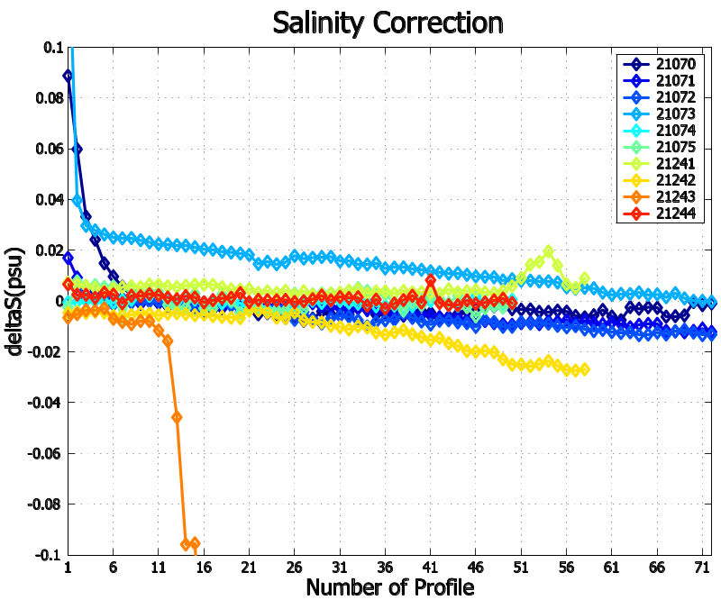

Fig. 2: Salinity corrections for the PALACE floats as a function of number of profile. Note that the color code is different from Fig. 1.

The deep pumping time of the first four floats was underestimated, preventing the floats from surfacing normally, after the first few profiles. Also as the deep pumping rate falls with battery voltage, this problem worsens over time in these four profilers. The profiling initially missed the mixed layer, then missed the most of the thermocline after one year or so. Fig. 3 shows a typical float temperature time series from one of these floats: 21071. This float was deployed at the center of the South Equatorial Current, which undergoes intense instability during the boreal summer–July-September (Feng and Wijffels, 2001). The float captured the instability waves, as seen from the temperature profiles, during July-September 2000. Note that the waves penetrate well below the thermocline into the deep ocean, which may cause concern when synthesizing the float data with satellite observations. By summer 2001, this float had drifted out of the intense instability region.
Also due to the ongoing La Niña event in the Pacific, the trade winds in the Pacific were intensified and the atmospheric convection over the maritime continent surrounding the Indonesian Archipelago is also intensified. Excessive rainfall was related to the anomalous convection and the freshened surface water was carried by the Indonesian Throughflow and Ekman transport into this region. The floats captured the associated freshening of the upper ocean, as seen from the float salinity data, and their comparison with upper ocean climatology. Fig. 4 shows salinity data from one of the float, 21074. The float started profiling from early August 2000. There is a clear annual signal in the upper ocean salinity. The salinity is freshest around August, less than 34 psu, which is not correlated with local freshwater forcing, indicating the remote Throughflow influence. Compared with a high-resolution seasonal climatology (Dunn and Ridgway, 2001), the surface layer salinity is fresher by about 0.3 psu on average. Fig. 5 shows the overall anomaly for all 10 floats from data in 1999 and 2000. While the freshening causes a saline stratification near the surface, it also causes a surface layer warming, likely due to the “barrier layer” effect. The anomalies exist when we corrected the effects due to the vertical thermocline motions (Fig. 5).

Reference

Dunn, J. R., Ridgway, K. R., 2001: Mapping ocean properties in regions of complex topography. Deep-Sea Research I, in press.
Feng, M., Wijffels, S., 2001: Intraseasonal variability in the South Equatorial Current in the eastern Indian Ocean. Journal of Physical Oceanography, in press.

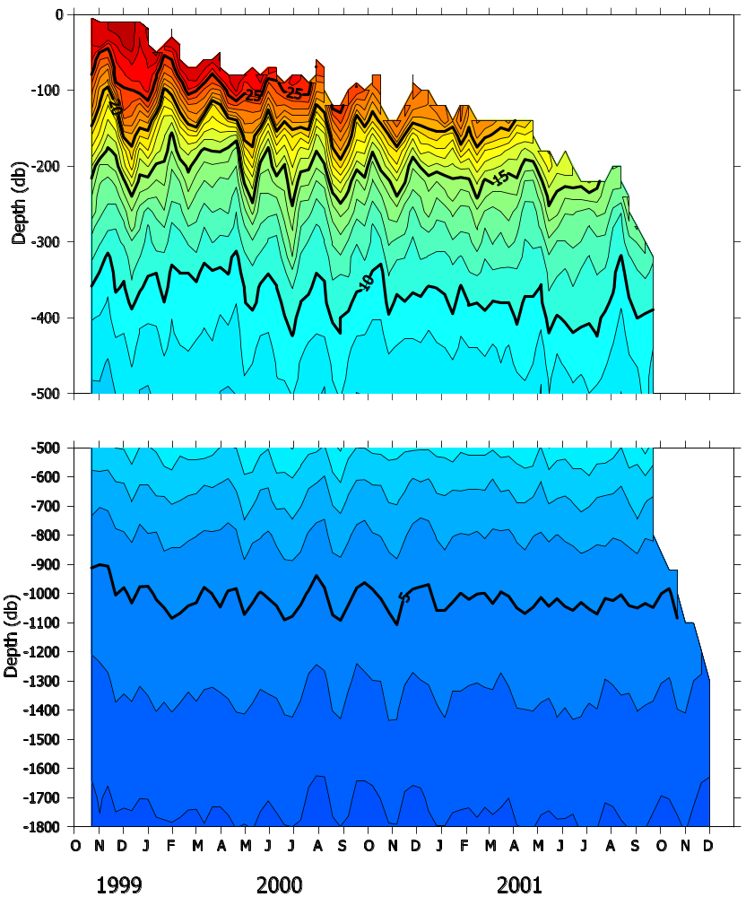

Fig. 3: Temperature profile time series from float 21071. The contour interval is 1ºC.
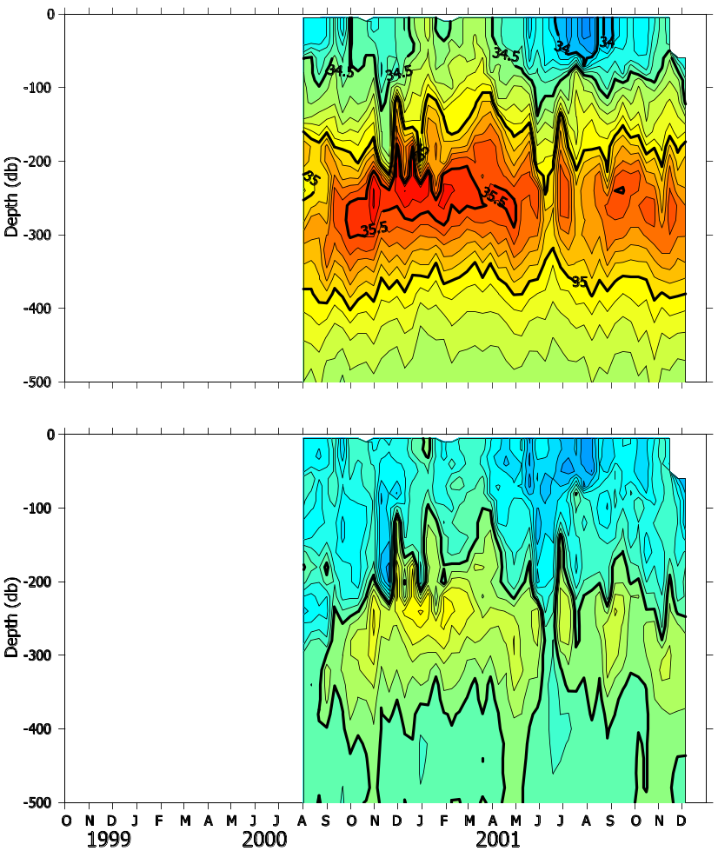
Fig. 4: Time series of salinity and anomaly relative to Dunn and Ridgway climatology. The contour spacing in the lower panel is 0.1 psu and blue is freshening.

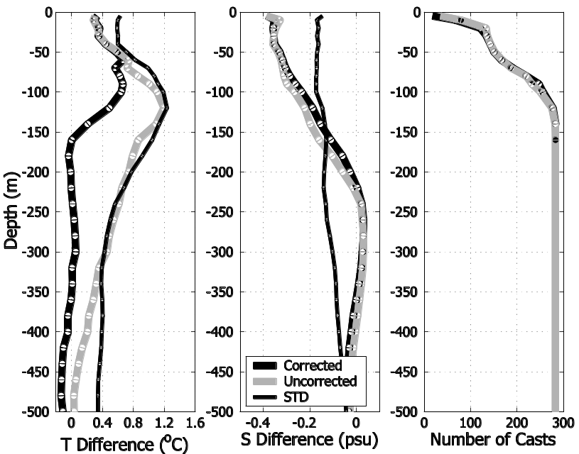
Fig. 5: Average anomalies of temperature (left) and salinity (middle) relative to the Dunn and Ridgway climatology. Number of casts used in averaging is shown in the right panel. The corrected averages are calculated by removing the vertical thermocline motion.

